Name:____________________________ Date:_____________________

Sticker Problems  1. I had 238 animal stickers in my book. On Monday, my teacher gave me 245 stickers. How many stickers do I have now? | 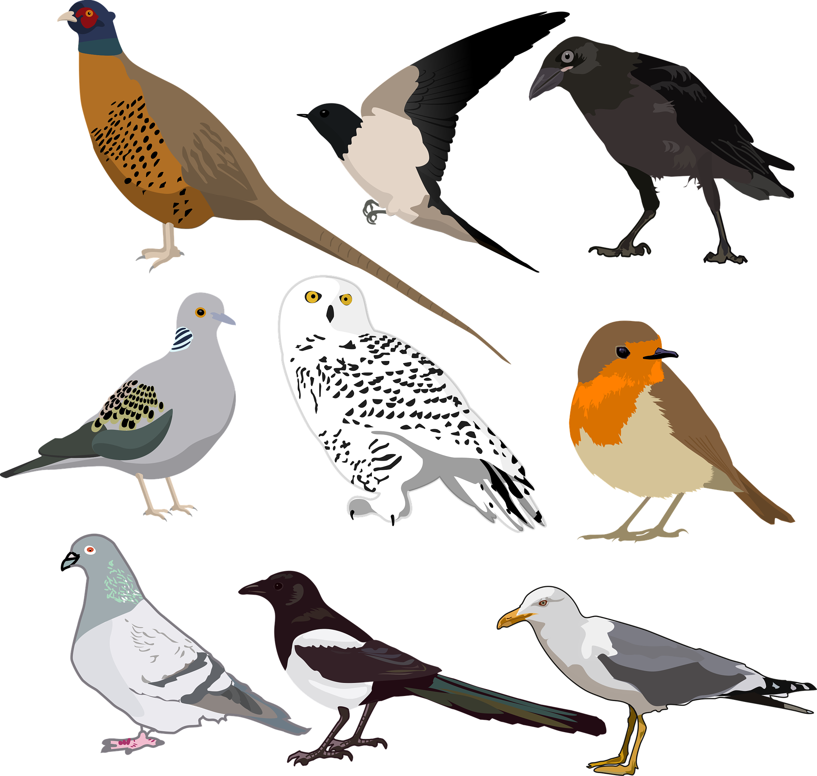
2. On Tuesday, I gave my friend 177 stickers.
How many stickers do I have now?

3. Four friends were comparing how many stickers they had.

Don said: “I have 25 stickers.”
Alana said: “I have 82 stickers.”
Amy said: “I have 10 more stickers than Don.”
Micah said: “I have 10 fewer stickers than Alana.”

a. How many stickers does each friend have?

b. How many stickers do the four friends have altogether?

